**Instructions**

Write an application that displays a JFrame containing the opening sentence from *A Christmas Carol*. Add a button to the frame in the JBookQuote program. When the user clicks the button, display the title of the book that contains the quote in the available JLabel using the setText() method.

An example of the program is shown below:

[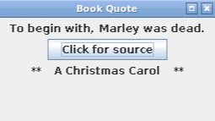](https://cdn.filestackcontent.com/xrDWrkCmRPuM26SvCxBI)

**Grading**

Write your Java code in the area on the right. Use the **Run** button to compile and run the code. Clicking the **Run Checks** button will run pre-configured tests against your code to calculate a grade.

Once you are happy with your results, click the **Submit** button to record your score.